Unity Team
Matteo Dell’Oro, Alfio Giuliano Faro, Gabriel Logronio

PROTOTYPE SCENOGRAPHY DOCUMENT

Purpose | Document containing setting and script of the prototype level
Creation date | 22-11-2017
Current owner | Alfio Giuliano Faro
Last modification | 11-12-2017

Revision History
Who | When | What
Faro | 22-11-2017 | Created this document
Faro | 23-11-2017 | Added Setting
Faro | 24-11-2017 | Added Script
Faro | 11-12-2017 | Added the difference between playable parts, dialogues, cutscenes and puzzles

Setting

At the start of the level, the group lands with the Tardis in the outskirts of a town, nearby a little rundown gas station with a shop on the road heading to the same city. The area is surrounded by a desert, with the air dry and dusty. The vegetation is poor, with just sporadic weeds and brambles growing here and there and some grass that have gone totally dry and yellowed, the ground is dry and bright brown. All together they make the landscape desolated and in ruins, as the sun is setting down. There is nobody around.

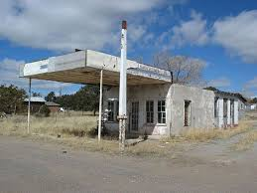
(A gas station in ruin near the landing point)

Not far from there the town can be noticed. In in the houses and the streets are just ruins of what they used to be. From a building the light from a huge factory can be seen and its noises resound through the walls. People who used to live there are disappeared, just few rabid dogs manage to live in the area also patrolled by cybermen.
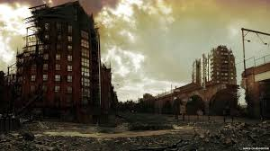
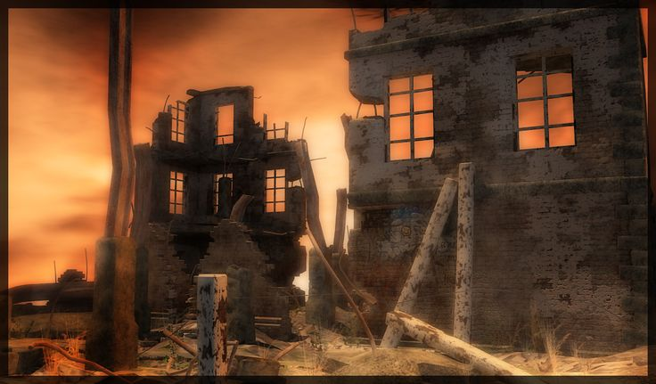
(The view of the factory from the town) (A view of the city, with buildings in ruins and a bridge)

The factory has a huge courtyard with some buildings, tanks, tubes, drills, bulldozers and quite a lot of materials used in the works. In the middle of the factory there’s a big tower.
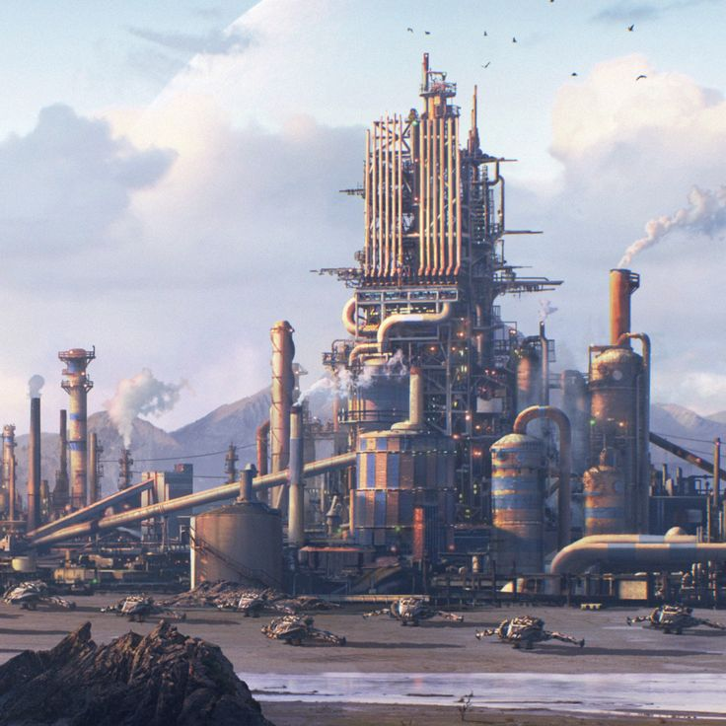
(A view of the factory from afar)

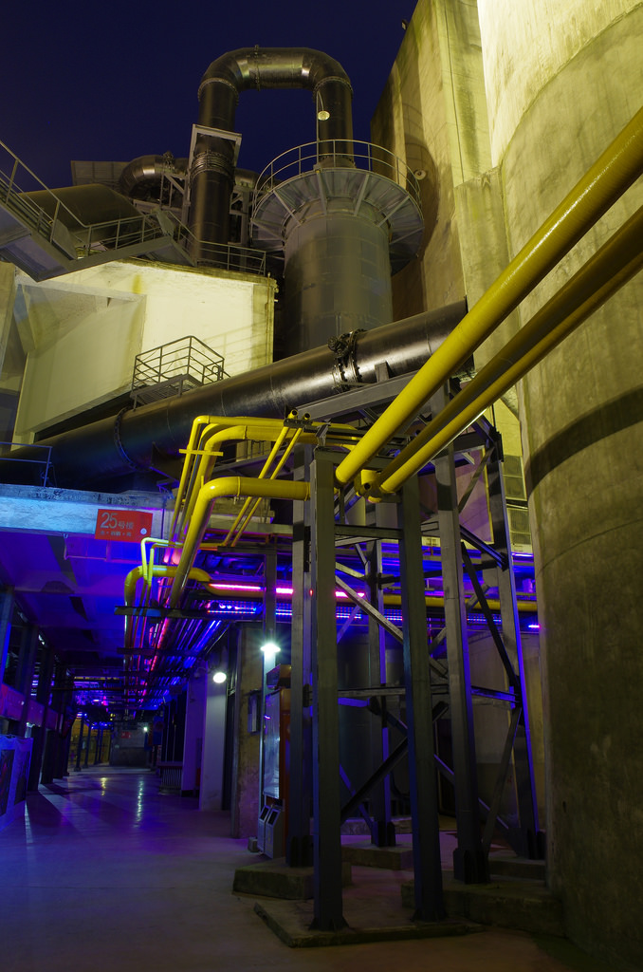
(A view from inside the factory, we can see tanks and tubes)

The corridors are wet and long, with some artificial neon on the roof. Everything is made out of iron and metal. The tubes run attached to the walls, and they change their paths only near a door. Many stairs and an elevator lead to the different floors, with a big door consisting in the entrance to the main hall. The main hall contains the production line, where a lot of cyberman and sontaran's armours are being assembled. The predominant colour are grey and black, with the tubes looking heavy and rusted. A strong smell of chemical agents is in the air, inside the rooms and the corridors. Sometimes cold air can be felt coming from outside through the cracks. The corridors are patrolled by some cybermen. The atmosphere is oppressive, the ambient is claustrophobic and the presence of cybermen make you feel haunted.

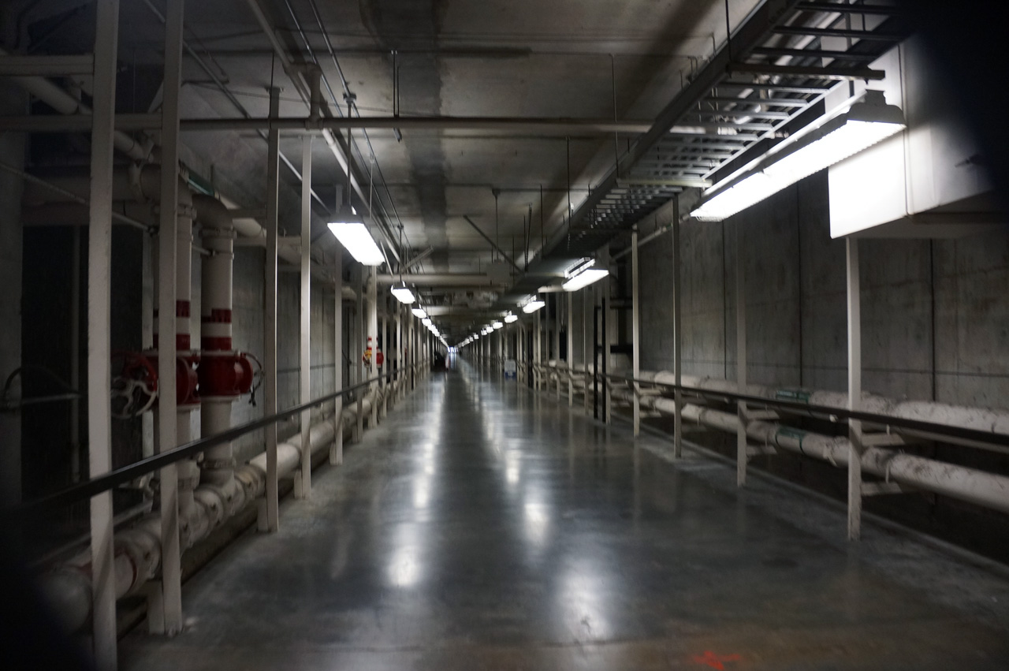
(An example of a corridor)

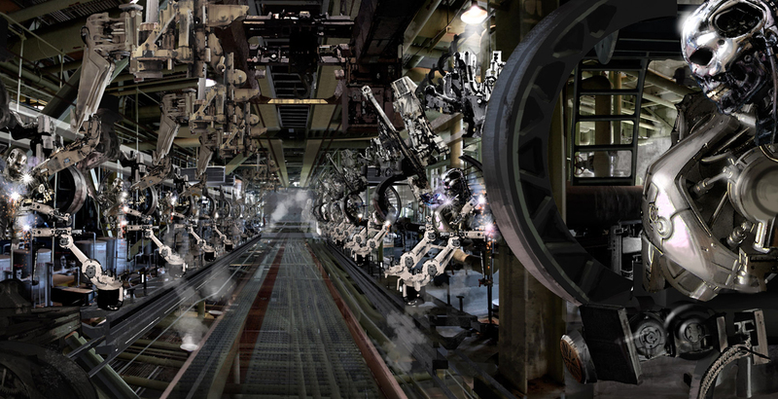
(A view of the main hall where the factory line of production is)

Inside a room you can find monitors, tables and some papers written by the scientists that work there. In another part of the factory you can find the dorms where the human workers are kept.

Some rooms are laboratories, where scientists work under the supervision of some cybermen.

Upstairs, on the top floor, you can find the control room, where Strax is located. This is a huge room with one big window in front of the entrance door, where you can look the landscape of the factory and the places around it. Just under the window there is a big desk with computers, monitors, buttons, and a chair where Strax is seat. The room is very bright, different from all the other rooms in the factory, the walls are white and the floor is polished and clean, made out of a bright and perfect grey material. The air inside is fresh and clean, not even outside the factory it is this pure. This room transmits a sensation of calmness, but you feel the electricity in the air, like that “calm before the storm”.

Script
In the dialogues lines will be divided between Alros, Ashildr(Me), Clara, Jack, Jenny.

Script | Type and description
"Finally we have landed" Jack says after that the Tardis stopped. The group gets out the Tardis. "Where are we?" asks Jenny while looking around. "I think we’re still on Earth" answers Clara, "Look there, it seems like a gas station or a little shop". "Let’s hope we find other beautiful travelling companions here" says Jack, looking at the girls, as they roll their eyes and snort at Jack's sentence.  The group heads to the gas station, once inside Ashildr says "Looks like they ran away in a hurry" while checking around with her weapon ready to fire. "It's strange" Alros picks up a bowl containing some beans, now dented and mouldy, "they fled so quickly that they didn't even take away all this food!". Me glances at Clara and says "I think we better check this place quickly and then leave". | Scripted sequence with dialogue  1
Inside a part of the roof is broken with the sun coming in. In the sky the last daylight is leaving early in the evening. No one is inside, but products are still on the shelves. The team can find some consumables items on the shelves. Jenny hacks a terminal in order to access the storage room in the back, where they find other useful resources. They then exit the small shop and head to the nearby town | Playing time with a puzzle
While walking around Clara asks Alros why he is so silent. "I'm worried about my brother, I hope he’s OK. I need to find him". "Don't worry, I'm sure he is fine!". | Scripted sequence with dialogue  2
The party follows the road until they reach a little town, now in ruins. The buildings are destroyed due to neglect and bad weather and the dust covers the streets. Here and there some plants can be spotted, but they’re just trunks without life. Jenny hacks the gates terminal and they get in but are immediately attacked by a group of patrolling cybermen. After defeating them they examine the body and find a radio signal heading to a nearby place, then they proceed to look around the city hoping to find something interesting. | Playing time with a puzzle
In a building they find a fresh corpse of someone who looks like a scientist with a badge still in his hand, with a note saying: “Dear Laura, we managed to escape,I’ll come back to free you too, just wait for me, your Mickey” Me picks it up saying “He won’t need it any more”. While exploring towards the source of the signal they get to a guard post filled with cybermen but they strangely do not attack on sight. | Scripted sequence with dialogue  3
On of the cyberman says “Show me your badge” with his rusty robotic voice. Me rapidly takes the pass that she previously got and shows it to the cybermen and they let the team pass without attacking them. “That was really, really strange, are they waiting for someone?” says Jenny, to whom Alros responds “I’ve never seen anything like that, I learned to fight them as soon as in sight” | Scripted sequence with dialogue  4
After a few minutes of exploration Clara shouts: "Hey! Look at that light!" pointing at a bright light coming from a building. From a window inside it the company can see a huge complex of buildings, tanks, and a big tower in the centre. "I think that's a factory" says Alros, "I'm sure that the cyberman has to come from there!". "It's possible" answers Me, looking at the complex. "We must find a way to get in!" the voice of Clara is firm and secure as she states, "I'm sure that the answers we’re looking for are in there!". | Scripted sequence with dialogue  5
They get out the building front the back door, following a road but all the cyborgs are alerted by the defeat of their fellow in the town. They get to a minefield patrolled by some cybermen and powered by four generators. | Playing time
Clara separates from the rest of the team in order to sneak and deactivate those generators, as a combat is not possible surrounded by all those invisible mines. After managing to deactivate them, both the cybermen and the mines in the area deactivate too, allowing the team to reach her. | Puzzle
"There is too much surveillance, it's impossible to get in from the front door without fighting, we must find another way to get in!" Clara says "Look, there is a little river right there, maybe we can use it to get to the sewers of the factory". | Scripted sequence with dialogue  6
The team explores the surrounding area in order to find a less guarded way to enter the facility. | Playing time
Clara was right, not too far away there is a gutter from where the water comes out in the river. "Maybe we should use it to get in" proposes Me. "Ok I’ll watch your back… what a back… ehm sorry I look back" says Jack, and immediately Clara taps him on the neck, while Alros laughs at the scene. | Scripted sequence with dialogue  7
"It's strange: this water does not smell like I expected, actually it does not smell at all!" says Alros looking around, "It's dirty, yes, but there are no 'dirty gifts'. I don't think it's the sewers, I think this water is just used in the factory in some sort of industrial process". "I agree " replicates Me. | Scripted sequence with dialogue  in the sewers  8
Finally they get in a huge empty room where the water comes in and gets out through the channel. The stairs inside are located next to a wall of the room. "Ok from now on we must be as careful as possible" orders Jack, and the group nods together. Our heroes leave the drain to get into an inner courtyard. | Scripted sequence with dialogue  at the end of the canal  9
They then explore the factory that is heavily patrolled by cybermen. They find the tower that they could see from far away, but the main entrance is too much controlled, so they search for another way to get in it. The team manages to find a little service elevator "Guys I think that this goes up, maybe we can find something there, but we need a pass as there’s nothing here I can connect with" states Jenny.  In the second floor of a building they find a room with inside there some tables with scientific stuff, monitors, and two cybermen. Our friends try to make a sneak attack and they manage to knock out the enemies without triggering the alarm. | Playing
"Ok, let's look for any clue" Clara says. In this room, in one monitor a note written by someone "This is the last time that I’m covering you, if they find out what you are thinking you are getting both of us killed! You know it is forbidden! Leave your desire for vengeance and try to live as long as you can Mikey! I love you, Laura". | Scripted sequence with dialogue  10
They find a big door with a big sign "Private access". Clara tries to open the door but it's locked, so Jenny tries and manages to hack the terminal connected to the door. The group explores another room of the complex where they find two cybermen that are controlling the work of few scientists. The group does another sneak attack and they succeed in defeating the cyborgs. | Playing with a puzzle
One of the scientist approaches Clara: "Many, many thanks! We’re glad for the help! They kept us here for so long".  "Who are you?" Clara asks. "I'm Michael Begance, the lead scientist in this lab. They have kept us here to produce cybermen and design armours, I don't know what the purpose of those machines is, but they treated us as slaves and..." his voice breaks as the man starts to cry "and they killed my wife, right in front of my eyes".  Alros tries to cheer up the man and asks "Do people call you Mikey around here?". The man looked like hit by a fist: "It’s just Laura who used to call me that way. " Alros takes out the note and gives it to the doctor. The man starts to cry again "Oh Laura what have I done?". Clara starts to talk: "We want to put an end to this, we don’t want anyone to suffer any more. But in order to do that, you need to help us". The man rises his head up, wipes the tears and says: "On the top floor of the tower you can find the commander of this place, he has control over all the cybermen, defeat him and you will free us all. Take this, it's my badge. You can enter the tower but it won’t let you go until the last floor; in order to do that you have to go to the office room, insert my card in the terminal and hack it increasing your permissions. If you succeed you will be able to reach the top floor and face the commander". Clara hugs the man, and with the group heads to the room where they the terminal is located. | Scripted sequence with dialogue  11
Inside this room there are other two cybermen guards, they defeat them and after cracking the terminal they get the permission. They come back to the elevator and go to the commander's room. The door is open as if he is expecting them. | Playing with a puzzle
"Good evening my friends" says the commander as soon as they enter the space "I'm Strax, and I welcome you to my kingdom. Unfortunately, you will not live long enough to enjoy it". The room is well-lighted, very big with a huge window to admire the landscape of the factory. He is standing between the window and his desk, looking outside and with his back to the group.  "You have to stop all of this!" cried Clara, "Enough people suffered already! Cut it off now or we will!"  "I dare you to try!" answered Strax, engaging the group in a fight. | Cutscene  12

